Samples

please write this paragraph in an introduction format. start with the sector followed by the problem followed by the solution. also at the end include some examples of how multiple businesses have used similar technologies to improve this business processes . use arguments,passive voice and direct speech The integration of artificial intelligence (AI) into the healthcare sector has emerged as a transformative force, reshaping the way medical services are delivered and accessed. With the proliferation of large language models (LLMs), such as OpenAI’s GPT series, these models have demonstrated remarkable capabilities in understanding and generating human-like text. However, tailoring these general-purpose models for domain-specific tasks, such as healthcare assistance, requires innovative approaches to ensure efficiency, relevance, and accessibility. This thesis, titled "Health Assistance through Fine-Tuned LoRA-Based Language Models," delves into the development of a specialized conversational AI system aimed at providing personalized health assistance and tips. The project is grounded in the Low-Rank Adaptation (LoRA) methodology, a cutting-edge technique for fine-tuning pre-trained language models. Unlike traditional fine-tuning methods that are computationally intensive and resource-heavy, LoRA modifies a small subset of a model's parameters by introducing low-rank matrix approximations. This not only reduces the computational burden but also allows for rapid adaptation of large models to specialized tasks with limited data. The primary motivation for this research lies in addressing the challenges faced by existing healthcare chatbots, including limited contextual understanding, lack of personalization, and the high cost of development and maintenance. By leveraging LoRA, this project seeks to develop a health assistance chatbot that is efficient, scalable, and capable of providing accurate, evidence-based responses to a diverse range of user queries. The scope of the chatbot includes providing general health tips, assisting users in identifying potential symptoms, and guiding them toward appropriate resources or medical professionals for further assistance. Unlike generic conversational agents, this system is designed to handle health-specific terminologies and contexts, making it a reliable first point of interaction for users seeking health-related advice.

**Introduction**

The healthcare sector is witnessing a technological revolution, with artificial intelligence (AI) emerging as a transformative force in reshaping how medical services are delivered and accessed. While large language models (LLMs) like OpenAI’s GPT series have showcased remarkable capabilities in understanding and generating human-like text, significant challenges persist. A critical issue lies in tailoring these general-purpose models to domain-specific tasks, such as healthcare assistance, without compromising efficiency, relevance, or accessibility.

The integration of domain-specific AI solutions has been hindered by limitations such as high computational requirements, lack of contextual understanding, and insufficient personalization. These constraints have made it difficult to create scalable and reliable healthcare chatbots that can serve as effective first points of interaction for patients. Addressing these gaps requires innovative approaches to fine-tune AI models for healthcare applications.

A promising solution to this challenge is explored in the thesis titled *"Health Assistance through Fine-Tuned LoRA-Based Language Models."* This project employs the Low-Rank Adaptation (LoRA) methodology, an advanced fine-tuning technique that modifies only a small subset of a model’s parameters by introducing low-rank matrix approximations. Unlike traditional methods that are resource-intensive and slow, LoRA reduces computational demands while enabling large models to rapidly adapt to specialized tasks with limited data. This approach not only enhances efficiency but also ensures scalability and accessibility for personalized health assistance.

The health assistance chatbot developed in this research aims to overcome existing limitations by providing accurate, evidence-based responses tailored to health-specific contexts. Its functionalities include offering general health tips, assisting users in identifying symptoms, and guiding them toward appropriate medical resources or professionals. Unlike generic chatbots, this system is equipped to handle complex health terminologies and personalized interactions, enhancing its reliability and utility.

Similar technologies have demonstrated transformative effects across industries. Businesses in the financial sector have utilized AI to create personalized customer support systems, while e-commerce platforms have employed it to develop recommendation engines tailored to individual preferences. In the healthcare domain itself, applications like IBM Watson Health and Babylon Health have set precedents for AI-driven diagnostics and virtual consultations. These examples underscore the profound potential of specialized AI systems in streamlining business processes and improving user experiences.

Prompt

please do not use specific technologies like lora and avoid extreme words like advanced. also please provide diverse examples instead of only from health sector. I also want only 2 paragraphs. and use compare and contrast words like however, in comparison to

**Introduction**

The healthcare sector is rapidly transforming through the integration of artificial intelligence (AI), which has begun to reshape how medical services are delivered and accessed. While large language models (LLMs) have shown exceptional potential in generating human-like text and assisting in various fields, their generic design often limits their application to specialized domains like healthcare. The challenge lies in adapting these models to provide accurate and personalized assistance efficiently. Existing healthcare chatbots frequently face issues such as limited contextual understanding and a lack of customization, which hinders their effectiveness. In comparison to generic AI solutions, a more focused approach is required to address the unique complexities of health-related interactions.

To bridge this gap, specialized AI solutions can deliver tailored assistance while maintaining efficiency and scalability. For instance, a healthcare chatbot can offer personalized health tips, symptom guidance, and recommendations for professional consultation, ensuring greater relevance and user satisfaction. This approach mirrors advancements in other industries, such as AI-driven customer service in retail, where virtual assistants provide individualized recommendations, and financial services, where automated systems handle queries about investments and loans with high precision. Similarly, in education, AI-based tutors have improved student engagement by delivering content tailored to individual learning needs. These examples demonstrate how domain-specific AI systems can refine processes, ensuring greater reliability and improved user outcomes when compared to their general-purpose counterparts.

please expand it to about 500 words

The healthcare sector is undergoing a significant transformation through the integration of artificial intelligence (AI), which is reshaping the delivery and accessibility of medical services. Large language models (LLMs) have demonstrated impressive capabilities in understanding and generating human-like text. However, their general-purpose design often limits their effectiveness in specialized domains like healthcare. Existing healthcare chatbots, for instance, frequently encounter challenges such as limited contextual understanding and a lack of personalization, which impede their effectiveness. In comparison to generic AI solutions, a more focused approach is necessary to address the unique complexities inherent in health-related interactions.

To bridge this gap, specialized AI solutions are being developed to provide tailored assistance while maintaining efficiency and scalability. For example, healthcare chatbots can now offer personalized health tips, symptom guidance, and recommendations for professional consultation, ensuring greater relevance and user satisfaction. This approach mirrors advancements in other industries. In retail, AI-driven customer service platforms utilize virtual assistants to provide individualized recommendations, enhancing the shopping experience. Similarly, in the financial sector, automated systems equipped with AI capabilities manage queries related to investments and loans with high precision, improving customer satisfaction and operational efficiency. In the field of education, AI-based tutors deliver content tailored to individual learning needs, thereby improving student engagement and outcomes. These examples demonstrate how domain-specific AI systems can refine processes, ensuring greater reliability and improved user experiences compared to their general-purpose counterparts.

**Introduction**

The healthcare sector is undergoing a remarkable transformation with the integration of artificial intelligence (AI), which is fundamentally altering how medical services are delivered and accessed. While large language models (LLMs) have demonstrated impressive capabilities in generating human-like text and supporting a variety of applications, their general-purpose design often limits their effectiveness in addressing specialized needs. This limitation is particularly evident in healthcare, where chatbots and virtual assistants frequently encounter challenges such as limited contextual understanding, poor adaptability to domain-specific language, and a lack of personalization. In comparison to these general models, domain-focused AI systems are better suited to tackling the unique complexities of health-related interactions, providing greater accuracy and relevance.

Tailored AI solutions are emerging to bridge these gaps, enabling systems to cater specifically to healthcare needs while ensuring efficiency and scalability. For instance, specialized chatbots can assist users with personalized health advice, symptom guidance, and professional consultation recommendations. Unlike generic conversational agents, these systems are equipped to understand and respond to health-specific terminologies and scenarios, enhancing their utility as reliable first points of interaction. This focused approach has parallels in other industries as well. In retail, AI-powered platforms use virtual assistants to provide personalized shopping recommendations, improving customer satisfaction and driving sales. Similarly, in the financial sector, AI-based systems manage customer inquiries related to investments, budgeting, and loans with precision, fostering trust and operational efficiency. Educational institutions, too, are leveraging AI-driven tutoring systems that adapt to individual student learning needs, increasing engagement and improving outcomes.

The potential benefits of domain-specific AI solutions extend beyond mere efficiency. They improve user experience by delivering personalized, contextually aware interactions that build trust and meet user expectations. For instance, businesses in manufacturing are employing AI to optimize production lines and predict equipment failures, ensuring smoother operations and reduced downtime. In the logistics sector, AI-driven systems are streamlining supply chain management by accurately forecasting demand and optimizing inventory levels. These applications showcase how AI, when tailored to specific industries, can solve nuanced challenges and create measurable value. In comparison to their generic counterparts, these systems offer more precise, reliable, and impactful solutions, demonstrating the advantages of specialized AI across diverse fields.

The integration of domain-specific AI systems has already proven successful in various industries, emphasizing the transformative potential of such approaches in healthcare. By learning from advancements in other sectors, healthcare AI solutions can further evolve to address their unique challenges, creating tools that not only improve efficiency but also offer personalized, meaningful interactions. As businesses across industries adopt and refine AI-driven systems, the healthcare sector has the opportunity to leverage these innovations to enhance service delivery, foster trust, and better meet the needs of patients and practitioners alike.

4o

**You said:**

also please create an image that best describes the paragraphs

**ChatGPT said:**

ChatGPT

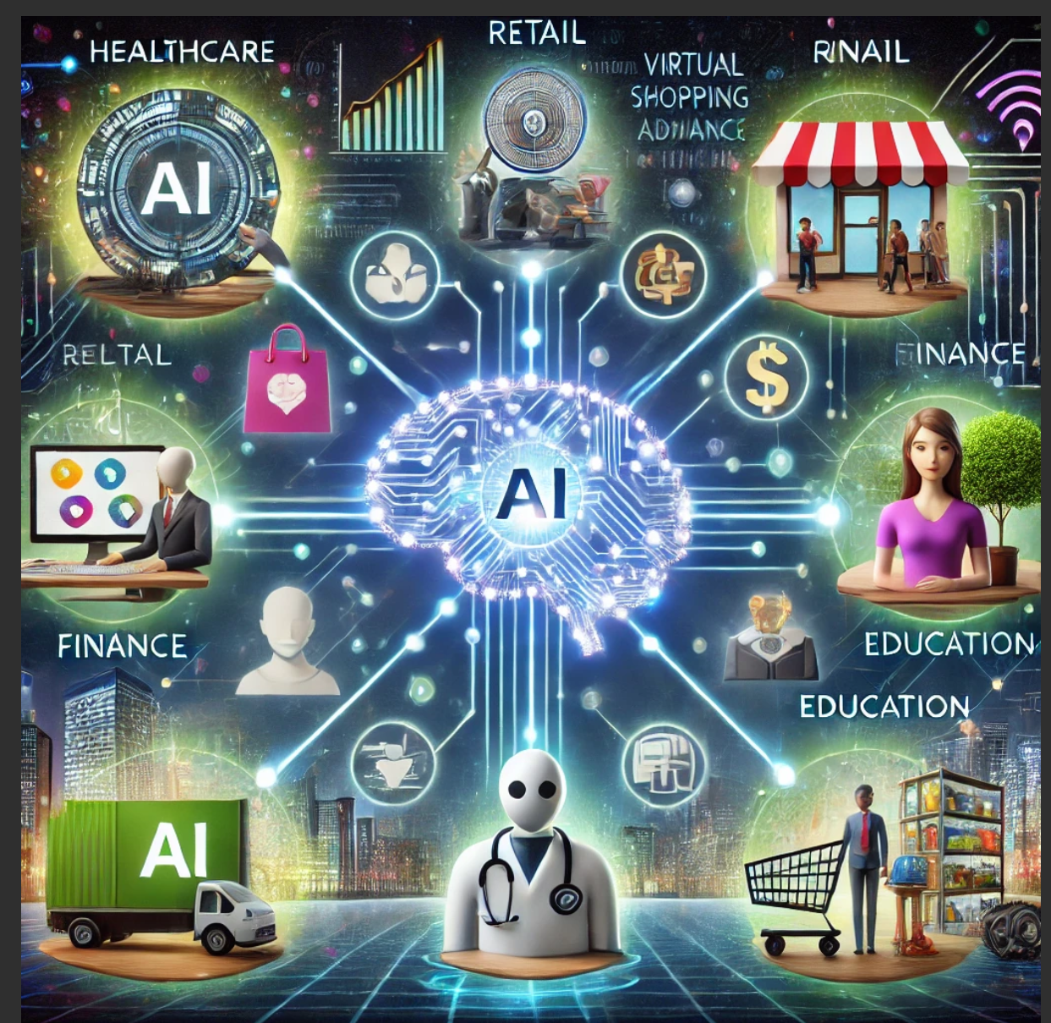

Here's an image representing the integration of AI across various sectors, including healthcare, retail, finance, education, and logistics, all interconnected to demonstrate its transformative potential. Let me know if you'd like to refine it further!

**You said:**

i want the image to describe only heathcare and i want minimum information in context to nepal

**ChatGPT said:**

ChatGPT



Here is an image illustrating the integration of AI in healthcare within the context of Nepal, highlighting a rural setting with technology and traditional elements. Let me know if you'd like to make further adjustments!

**You said:**

i want a nepalese hospital instead

**ChatGPT said:**

ChatGPT

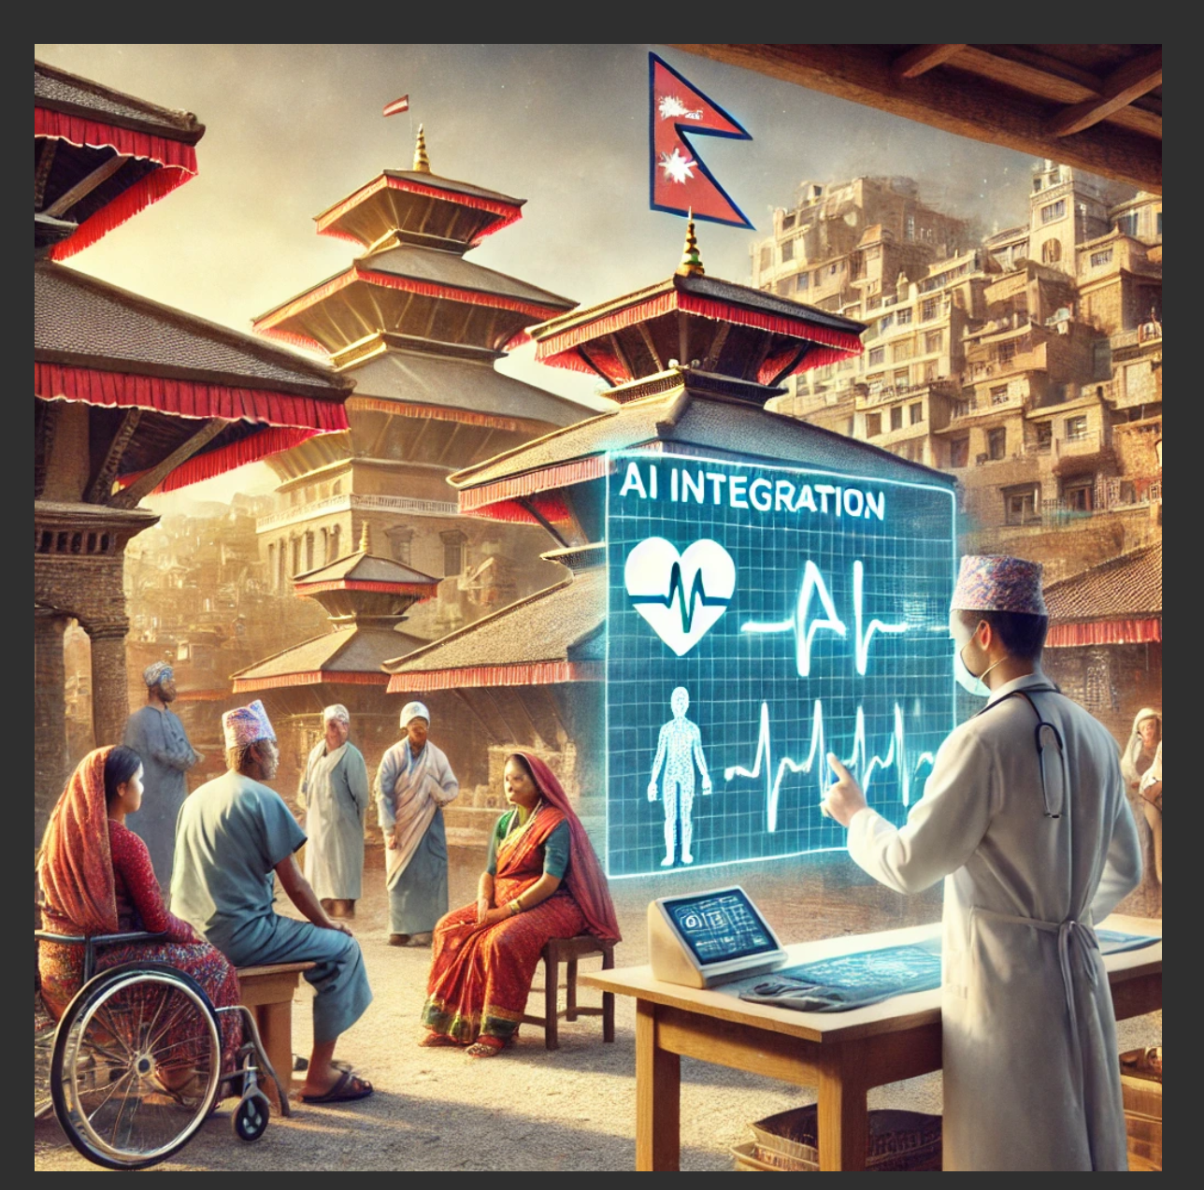

Here is an image depicting AI integration in a Nepali hospital, showcasing a blend of modern medical technology and traditional Nepali cultural elements. Let me know if there’s anything you’d like adjusted!